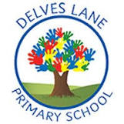 | Autumn Newsletter
Important information | Welcome to Year 6
 | 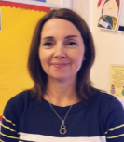  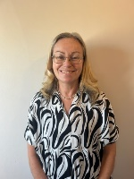 | My name is Mrs. Donnelly and I will be teaching Oak Class this year.  My name is Mrs Schenker and I will be teaching in Oak Class this year.
 | 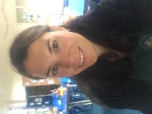 | My name is Mrs. Kelly-Fraser and I will be teaching Beech Class this year.
This term, our PE day will be a Monday. Please ensure that you arrive at school prepared with a suitable PE kit which consists of navy-blue shorts or jogging bottoms, a white T- shirt, and a pair of black trainers or sand shoes.

Homework will be given out on a Friday afternoon and will consist of one short grammar activity and one short maths activity which will consolidate learning that has taken place in the classroom during the week. Homework is to be returned to class by the following Tuesday. Spellings will come home every Monday (Oak) or Friday(Beech) for the children to practise in preparation for their spelling test every Friday.

In addition to this weekly homework, children are expected to read at home daily. Children will bring home a reading book of their choosing and should read with an adult at least three times per week.
Reading and phonics | This term, we will be focusing on developing our literal retrieval skills within out guided reading as well as giving special attention to developing our vocabulary and inference and deduction skills.  This term, in Oak class we will be reading the brilliant book ‘Holes’ by Louis Sacher as our class novel. In Beech class we will be reading ‘Rooftoppers’ by Katherine Rundell. |  |  | 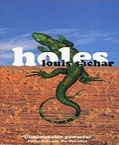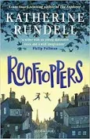
Writing | In writing, we will be reading the poem ‘The City of Silence’ and using this as a stimulus to write our own poems. We will focus on the structure of the poem and the use of repetition. We will also be creating our very own spy gadgets and advertising these using some very persuasive language. In the second half of this term, we will read the picture book ‘My Secret Bully’  by Trudy Ludwig and explore the narrative of this story and how the author develops the characterisation through action and dialogue. We will draw on this structure to build our own stories about the two main protagonists-Monica and Katie.
Maths | In maths this term we will be learning about the following topics:  - Place Value  - Four Operations  - Fractions  - Converting Units
Science | In Science this half term, we will be asking the question: How do we classify organisms?  In this topic, we will describe how living things are classified into broad groups according to common observable characteristics and based on similarities and differences, including microorganisms, plants and animals  After half term, we will be asking the question: How do electrical circuits work?  In this topic, we are going to plan different types of scientific enquiries to answer questions, including recognising and controlling variables where necessary, making accurate measurements and recording the data in different forms.
History | This term, we will be learning about the Mayan Civilisation. In this topic, we will be taking a trip deep into the rainforests of Central America as we explore Mayan ruins and from there embark on a journey that will help us uncover the life, society and civilisation of both ancient and modern Mayan people.
Geography | In geography this term we will be learning about South America. We will learn about the countries, culture and geography of this fascinating continent. We will learn about the climate, the geographical features, the industries and the people of South America through a range of activities, giving us an insight into how life in South America is different to life here in the UK.
Art | In art this term, we will be asking the question: How did Frida Kahlo create art?  We will be examining the artwork of this Mexican artist and using her focus on self-portraits as a stimulus for painting our own. |  |  | 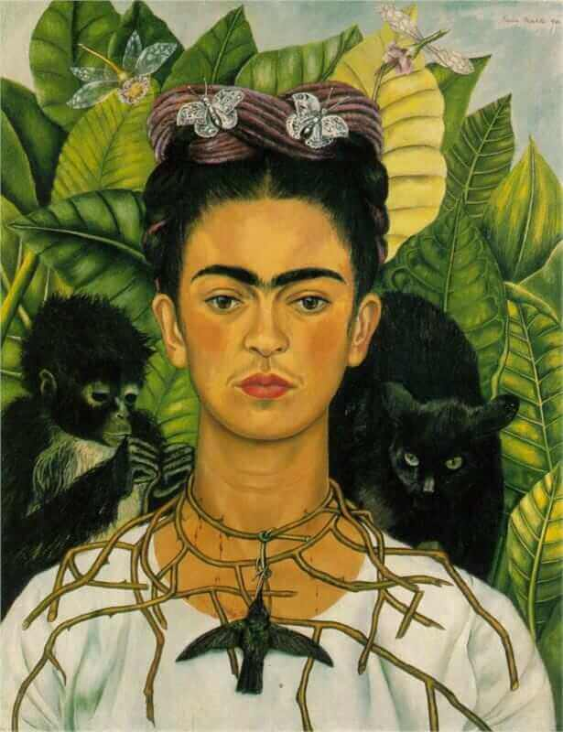
Design and Technology | In DT this term, we will be designing our own Christmas cushions.  We will look at a range of different existing products and analyse them for the materials used and how they are put together. We will develop our skills in sewing before designing and making our very own cushions.
RE | In RE this term, we will be investigating religious diversity in our area and finding out more about Islam and the Muslim faith.  After half term and in the lead up to Christmas, we will be learning about what the gospels tell us about the birth of Jesus.
PE |  |  | This half term, we will develop our skills in football and swimming.  After half term, we will focus on developing our knowledge and understanding of handball with a particular focus on throwing and catching.
PHSE | 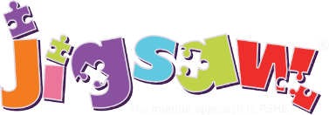 |  | In PSHE this term, we will be focusing on the units:  Being Me In My World (Setting and achieving personal goals) and  Celebrating Differences (Examining different types of discrimination and bullying)
Computing | In computing this term, we will be learning about the following topics:  -Coding- To design a playable game looking at the use of functions  -Online safety – To look at personal information and benefits and risks of sharing this.  -Spreadsheets- to use a spreadsheet to model a real-life situation.
Music | This term, children will learn the building blocks of music by learning about pulse- the ability to keep a steady beat taught through a number of musical games. The next step is to learn about rhythm – a regular repeated pattern of musical sounds. This will be done by learning and copying back short patterns. Learning that rhythms are patterns or beats and they can be made up of different lengths of notes. Finally, with this knowledge they can begin to understand about melody- a sequence of notes that is musically satisfactory- a tune. Children will learn a number of songs developing good vocal production and sense of pitch, pupils will be able to sing in harmony. Children will be able to perform to an audience the songs and begin to sing from memory. Children will have the opportunity to become skilled in using instruments, playing as a whole class, a piece of music.
MFL | In French this term, we will be learning how to greet each other, introduce ourselves, count to 20, tell each other our age and say where we live.

