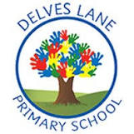 | Autumn Newsletter
Important information | Welcome to Year 5!
 |  | My name is Mr. Turnbull and I will be teaching in Year 5 this year.
 | My name is Mrs Clarke and I will be supporting in Year 5 this year.
 | 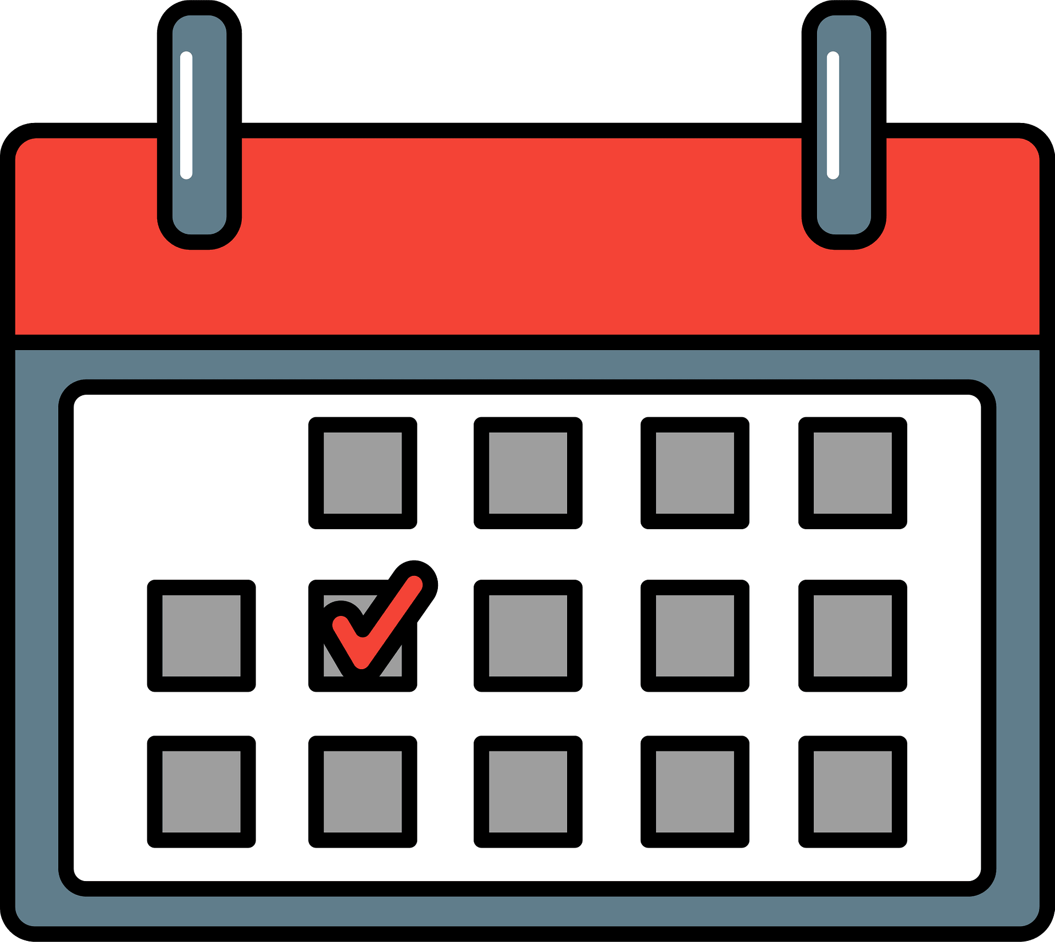 | This term, our PE day will be Tuesday. Please ensure that you arrive at school wearing our PE kit which consists of navy-blue/ black shorts, leggings or jogging bottoms, a white T-shirt and appropriate sports footwear.  In Year 5, children are expected to read daily. Children will bring home a reading book which they have chosen independently to promote reading for pleasure and they should read with an adult regularly both in school and at home. Children will be reminded to take their books and reading records home every night and these should be returned to school each morning.
Reading | This term, we will be focusing on developing our literal retrieval skills within our guided reading as well as giving special attention to developing our vocabulary through reading a wide variety of text types and genres.  We will be reading ‘Fing’ by David Walliams before selecting a new class text written by one of our class authors; Malorie Blackman, J.K Rowling, Sophie Anderson or Michael Morpurgo. |  |  |  | 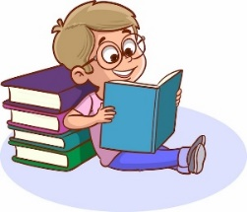
Writing | 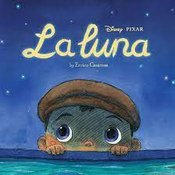 |  |  | This term, we will begin by using the Disney short story ‘La Luna’ as a focus for developing our writing. We will begin by learning and retelling the story orally and using drama, we will use pictures to help us to sequence the story, we will explore character emotions and finally we will write our own imitated versions of the story. Afterwards, we will attempt to innovate the story in creative ways such as changing characters, settings or events before inventing our very own Journey Tale.  We will also use this stimulus to write a non-fiction diary entry and instructions.
Maths | This term, we will focus on developing our understanding of place value, addition and subtraction, multiplication and division and fractions.  Within place value; we will recap Roman numerals to 1000, we will practise reading and writing numbers up to 1,000,000 and we will revise rounding numbers.  Within calculation; we will apply mental methods, we will practise formal written methods, we will use our estimating skills, we will learn about factors, multiples, cubes and primes and attempt to multiply and we will divide by 10, 100 or 1000 efficiently.  Within fractions; we will explore equivalent fractions, we will convert between mixed numbers and improper fractions, we will practise ordering fractions and we will attempt to add and subtract fractions in different formats. |  |  |  | 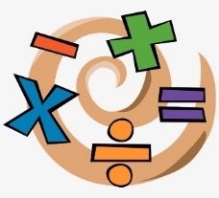
Science | 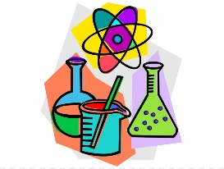 |  | In Science this half term, we will be exploring how materials can change.  After half term, we will be learning about forces and how they can be helpful.
History | In history this term, we will be the Viking and Anglo-Saxon struggle for the Kingdom of England to the time of Edward the Confessor |  |  |  | 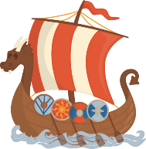
Geography |  |  |  | In geography this term, we will learn about Scandinavia. We will be identifying the location of countries, exploring their physical features and comparing its human geography to that of the UK.
Art | In Art this term, our theme is Graffiti. We will be exploring public perceptions on whether graffiti is are or vandalism and learn about prominent artists in this field such as Banksy.
D&T |  |  |  | In DT this term, we will be exploring the parts of mechanised toys. We will explore how these toys move and attempt to create our own examples.
RE | In RE this half term, we will be learning about Jewish worship and community life. We will learn about the key feature of worships and how faith effects the community as a whole. After half term, we will also be exploring Christianity a the Christmas journey. |  |  |  | 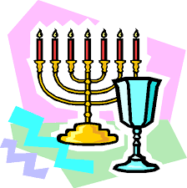
PE | 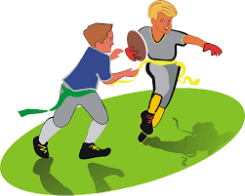 |  |  | In PE this term, we will be learning the game of tag rugby. We will apply relevant skills through a wide range of games and activities and complete with peers as part of a team.
PHSE | In PHSE this half term, we will think about ‘Being Me’ and what this means. After half term, we will also be ‘Celebrating Differences’. As part of this topic, we will be thinking about what makes us special and how this is different for everybody.
Computing | 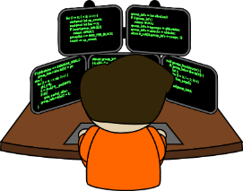 |  |  | This term in computing, we will learn about coding. We will revisit what coding is and how we can create a computer program using objects, actions and events.
Music | In music this term, we will be developing our understanding of pulse and rhythm. We will be learning about time signatures and musical notation.
MFL | 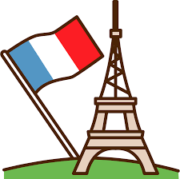 |  |  | In French this term, we will be learning about the four seasons. We will learn the name of each season and explore associated vocabulary.

