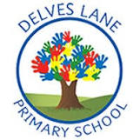 | Autumn Newsletter
Important information | Welcome to Year 4!
 |  | My name is Miss Jones and I will be teaching in Year 4 (Birch Class) this year.
 | My name is Mrs Crompton and I will be teaching in Year 4 (Elm Class) this year.
 | 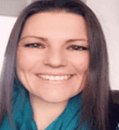 | My name is Mrs. Teneur and I will be supporting in Year 4 this year.
This term, Our PE day will be a Wednesday. Please ensure that children arrive at school wearing a suitable PE kit which consists of dark (navy blue, grey or black) shorts, leggings or jogging bottoms, a white t-shirt (these were sent home at the beginning of the year), and a pair of suitable trainers or sand shoes. During the colder months, children can wear their school jumper, too!

At DLPS we are trying to be eco-friendly! In an attempt to limit paper usage, Y4 will have paperless homework! This will be set on a Friday afternoon and will consist of:
- A set of spellings to practise on Spelling Shed – these will be tested the following Friday.
- Times tables to practise on TTRS – these will be tested the following Friday.
Homework is expected to be completed by the following Friday. If children cannot access Spelling Shed or TTRS, please don’t hesitate to contact the school for alternative arrangements to be made.

In addition to the weekly homework above, children are expected to read at home daily. Children will bring home a reading book and reading record every day and must read with an adult a minimum of three times per week. House points are up for grabs for every time children read at home!
Reading and phonics | This term, we will be focusing on developing our literal retrieval skills within out guided reading as well as giving special attention to developing our vocabulary through reading a wide variety of text types and genres.  This half term, Birch Class are reading Gangsta Granny as our class novel. Elm Class are reading A boy with the power of a star phoenix by SF Said as our class novel. After half term, we will vote for a new class novel from authors such as SF Said, Tom Fletcher, CS Lewis and Jenny McLachlan! |  |  | 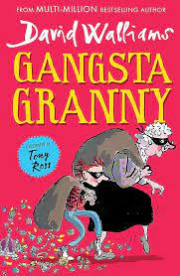 |  | 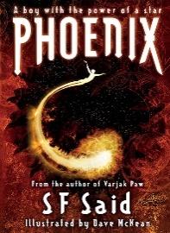
Writing | 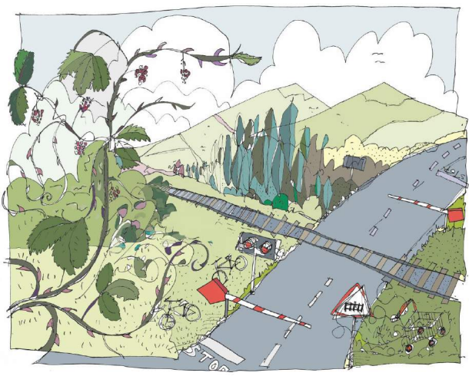 |  | This half term, we will focus our writing around the Pie Corbett text “Keep off the Tracks”. We will begin by recapping our Y3 skills before producing some descriptive writing using noun phrases and the ‘show, not tell’ technique. Following this, we will invent our own version of the warning tale, producing our own characters and setting. To end the half term, we will look at diary entries as a non-fiction text, retelling the story as a diary entry from the point of view of one of the characters.
 | After half term, we will focus our writing around the Pie Corbett text “The Game”, a text based on the story ‘Jumanji’. We will really enjoy producing our own games and characters, deciding what terrifying, magical or mythical creatures will appear from inside the game.  For our non-fiction writing, we will write instructions to help people understand how to play our games (if they dare!) |  |  | 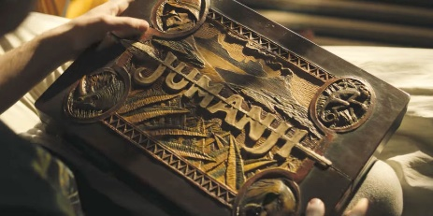
Maths | This term, we will focus on developing our understanding of place value and addition and subtraction.  Within place value, we will be looking at numbers up to 10,000. We will develop our skills in reading these numbers, building them using practical tools, partitioning them in different ways, comparing and ordering them, placing them on number lines, rounding them to the nearest 10, 100 and 1000, and we will learn about Roman numerals up to 1000.  Within addition and subtraction, we will develop our understanding of mental and written methods of calculation and use our knowledge to help us to solve problems.  After half term, we will look at area of rectilinear shapes by counting squares. We will also look at recalling multiplication and division facts up to the 12 times table. |  |  | 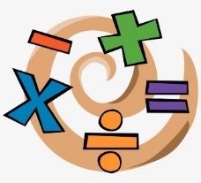
Science | 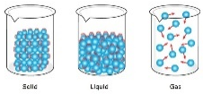 | 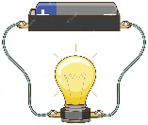 | In Science this half term, we will be learning about what our world is made up of. We will use cubes to help us model what particles are like in different materials (solids, liquids and gases). We will also look at the processes involved in changing these states of matter such as melting, evaporating, condensing and freezing.  After half term, we will develop our understanding of electricity, we will learn about how circuits are constructed and make predictions about whether a circuit will work or not. We will learn about how to stay safe around electricity as well as learning about conductors and insulators and which materials are best to use for switches. Finally, we will investigate different ways to make our bulbs brighter within our circuits.
History | This term, Year 4 will be learning about Ancient Rome.  We will think about where and when Ancient Rome existed. How it was founded, what daily life was like in Ancient Rome, What the Ancient Romans believes (Gods and Goddesses), about how they made decisions using the senate and finally how they grew to become an empire. |  |  | 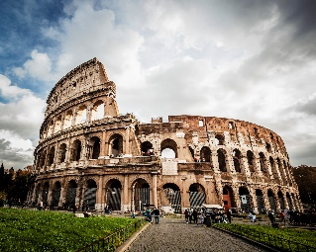
Geography | 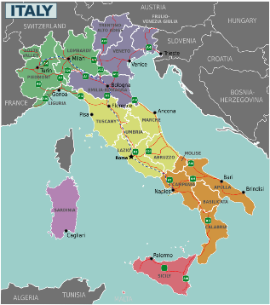 |  | In geography this term, we will learn about what Italy is like today. We will learn about the location of Italy and its surrounding countries and seas as well as some aspects of Italy’s human and physical geography. We will learn about the culture and famous landmarks that can be found within Italy. This will link to our learning about Ancient Rome.
Art | In Art this term, we will be learning what constitutes art and why people's opinions on what art is differ, before delving into the Pop art movement, investigating a variety of works by Warhol and other Pop art artists.  We will use techniques and style of Andy Warhol to help us to create our own portraits.
Design and Technology | 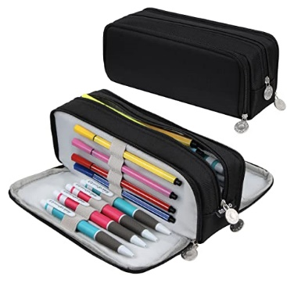 |  | In DT this term, we will be learning about pencil cases.  We will look at a range of different existing products and analyse them for the materials used and how they open. We will develop our skills in sewing before designing and making our own pencils cases using our new sewing techniques. We will then use our new skills to create a special item for the Christmas Fayre!
RE | In RE this term, we will be learning about the theme of identity and belonging. We will think about how different religions have their own identity and what it means to belong to a religion or any group within society. |  |  | 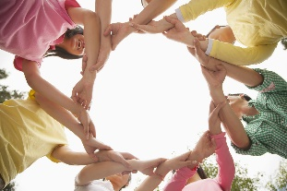
PE |  |  | This half term, we will develop our skills in bench ball with a particular focus on throwing, catching, intercepting and general rules of play.  After half term, we will focus on Athletics. We will think about running technique and how we must change our technique depending on whether we are running short distance, medium distance or long-distance races.
PHSE | In PHSE this term, we will think about ‘being me’ and ‘celebrating differences’. We will think about what makes us special and unique and how this is different for everybody.
Computing | 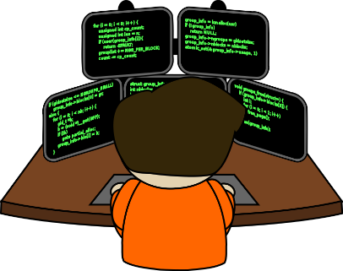 |  | This term in computing, we will learn about coding. We will learn about what coding is and how we can create codes which give computers instructions so that they know what to do.
Music | Y4 are extremely lucky to be receiving weekly ukulele lessons until the summer term! In these lessons, we will develop our musicianship through musical games, movement and singing, working on chords and strumming to play a variety of songs!
MFL | 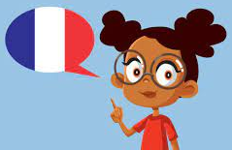 |  | In French, we will be looking at all the different names for different fruits in French.

