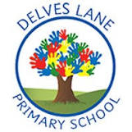 | Autumn Newsletter
 | Welcome to Year 3!
 | 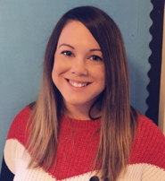 | My name is Mrs Randell and I will be teaching in Year 3 this year.
 | My name is Miss Forbes and I will be teaching in Year 3 this year.
 | 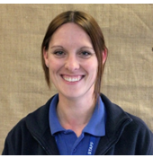 | My name is Miss Burnett and I will be supporting in Year 3 this year.
Important informati0n |  | This term, Our PE day will be Thursday. Please ensure that you arrive at school prepared with a suitable PE kit which consists of navy-blue shorts or jogging bottoms, a white T-shirt, and a pair of black trainers or sand shoes.  Homework will be given out on a Friday afternoon and will consist of a set of one short literacy activity and one short maths activity which will consolidate learning that has taken place in the classroom during the week.  Homework is to be returned to class by the following Thursday.  In addition to this weekly homework, children are expected to read at home daily. Children will bring home a reading book and must read with an adult a minimum of three times per week. Reading books are expected in school every day.
Reading and phonics | This term, we will be revisiting and consolidating our Sounds-Write phonics programme as well as developing our vocabulary through reading a variety of text types and genres. This half term we will be reading graphic novels such as Tom Gates and Bad Guys. |  |  | 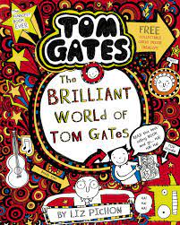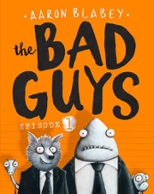
Writing | 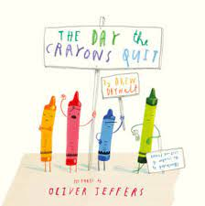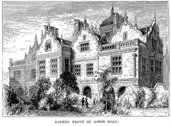 |  | This half-term, we will be using the story of ‘The Day the Crayon’s Quit’ as a focus for developing our writing. We will begin by learning and retelling one of the crayon’s letters orally and then change the text to make it our own. We will be focussing on using contractions and adjectives in our writing.  After half term, we will be using the suspense tale ‘The Manor House’ as a focus for developing our writing. We will begin learning and retelling the text orally and then change it to make a suspense tale of our own. We will be focussing on using paragraphs in our writing and using a detailed setting description to hook the reader.
Maths | This term, we will focus on developing our understanding of place value and addition and subtraction.  Within place value, we will be looking at numbers up to 1,000, suing hundreds, tens and ones. We will develop our skills in reading these numbers, building them using practical tools, partitioning them in different ways, comparing and ordering them and placing them on number lines.  Within addition and subtraction, we will develop our understanding of mental and written methods of calculation, including ‘column methods’ and use our knowledge to help us to solve problems. |  |  | 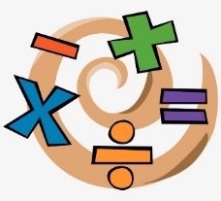
Science | 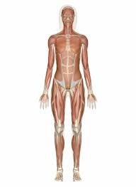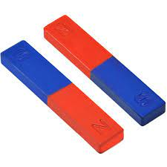 |  | In Science this half term, we will be learning about health and movement and how our bodies use muscles to move. We will begin to understand the importance of food to give us energy and learn what a balanced diet is by grouping food types.  After half term, we will explore forces and magnets using the vocabulary ‘repel’ and ‘attract.’ We will conduct experiments to find out what the ‘poles’ of a magnet do and which materials are most attracted to magnets.
History | This term, Year 3 will be learning about our Prehistoric world.  We will explore the Stone Age, Iron Age and Bronze Age and discover the daily lives of earliest man. We will discover the evolution of tools from stone to bronze, then iron, and how the invention of farming changed the way we live. |  |  | 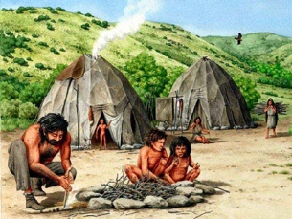
Geography | 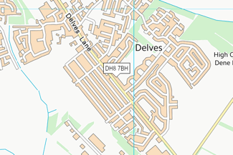 |  | In geography this term, we will be learning about our Local area of Delves Lane. We will explore the services available to the public in our area and use Google Earth to locate them. We explore the human and physical geography in our area and use maps to plot their location.
Art | In Art this term, we will be investigating patterns and which artists use them. We will look at symmetry, rotation and reflections within patterns and then design and create our own using stencils. |  |  | 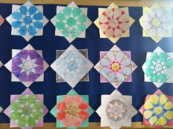
Design and Technology | 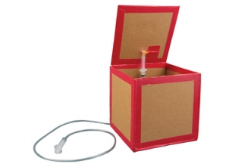 |  | In DT this term, we will be learning about pneumatic systems and how the flow of air can make something move.  We will look at a range of different existing products and test how they open. We will then design our own moving objects to sell at our school Christmas fayre!
RE | In RE this term, we will be looking at different representations of Jesus and reading some of the Gospels. We will explore the Christmas Journey and the importance of Bethlehem to Christians. |  |  | 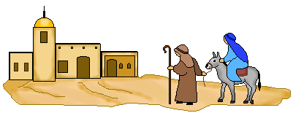
PE | 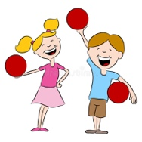 |  | This half term, we will develop our skills in Tennis, focussing on sending and receiving a ball with our hands and then progressing to using rackets.  After half term, we will focus on developing our knowledge and understanding of dodgeball with a particular focus on throwing and catching.
PHSE | In PHSE this term, we will think about ‘being me’ and ‘celebrating differences.’ We will think about what makes us special and unique and how this is different for everybody.
Computing | 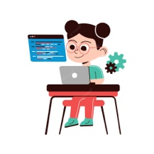 |  | This term in computing, we will learn about coding. We will learn about what coding is and how we can create codes which give computers instructions so that they know what to do.
Music | In music, |  |  | 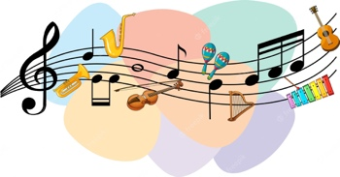
MFL | 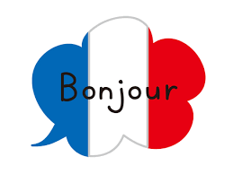 |  | We will be introduced to the French language in Year 3 using our new ‘Language Angels’ program. We will begin this term by learning how to say basic greetings in French, as well as saying numbers to 10 and colours.

