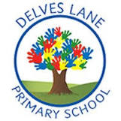 | Autumn Newsletter
Important information | Welcome to Year 1!
 |  | My name is Mr. McMeiken and I will be teaching in Year 1 this year.
 | My name is Miss Kirkbride and I will be teaching in Year 1 this year.
 | 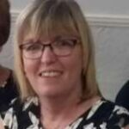 | My name is Mrs. Winskill and I will be supporting in Year 1 this year.
 | 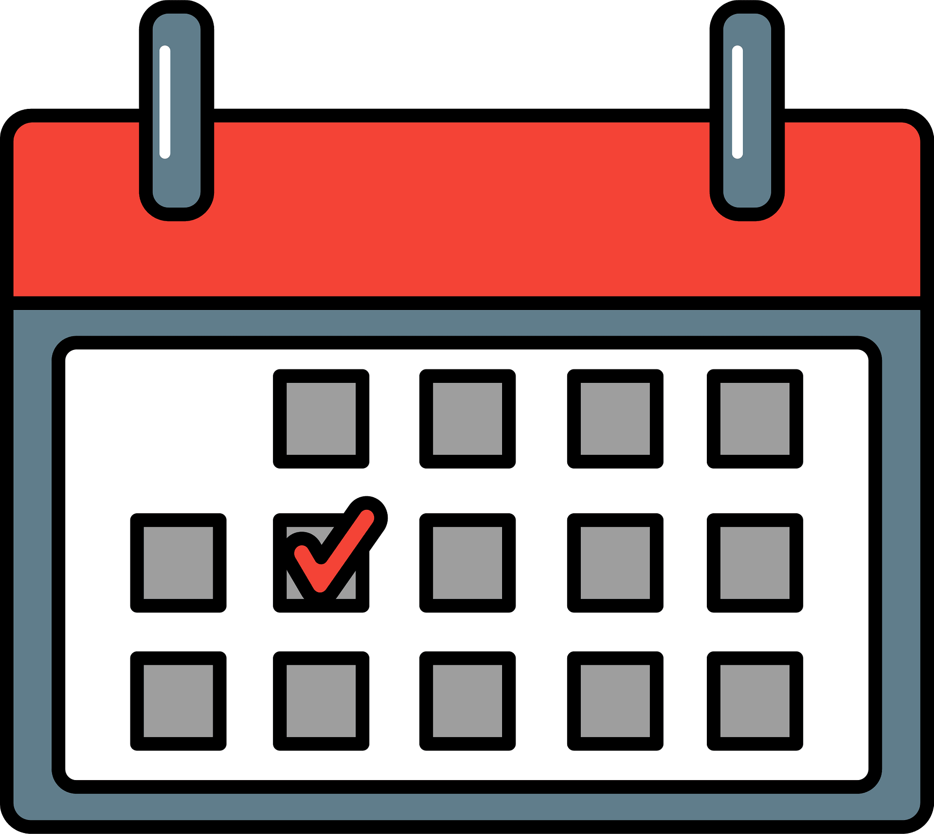 | This term, Our PE days will be Tuesday and Wednesday. Please ensure that you arrive at school prepared with a suitable PE kit which consists of navy-blue shorts or jogging bottoms, a white T-shirt, and a pair of black trainers or sand shoes.  In Year 1, children are expected to read at home daily. Children will bring home a reading book which matches their phonic ability and must read with an adult a minimum of three times per week. Children’s book bags will be sent home every night and must be returned to school each morning.
Reading and phonics | In phonics this term, we will continue to work on our blending and segmenting skills. After revising some of the word structures and two letter one spelling sounds we learnt in reception we will begin learning the extended code. The extended code teaches us different spellings of different vowel sounds. This will include new books and activities that the children will complete. |  |  | 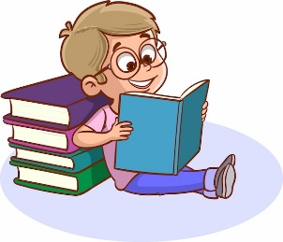
Writing | 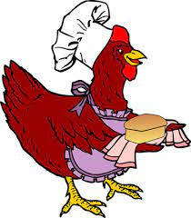 |  | This half-term, we will be using the story of ‘The Little Red Hen’ as a focus for developing our writing. We will begin by learning and retelling the story orally and using drama, we will use pictures to help us to sequence the story, we will use pictures from the story and speech bubbles to help us begin writing, and finally we will write the story.
 | After half-term, we will use the story ‘monkey see, monkey do’ as a focus for developing our writing. We will begin by learning and retelling the story orally and using drama, we will use pictures to help us to sequence the story, we will use pictures from the story and speech bubbles to help us begin writing, and finally we will write the story. |  |  | 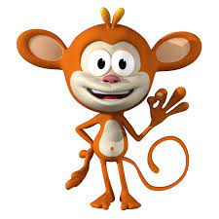
Maths | This term, we will focus on developing our understanding of place value, addition and subtraction and shapes.  Within place value, we will be looking at numbers up to 10. We will think about how we can count these numbers, represent them in different ways, write them, order them and compare them.  We will then think about adding and subtracting numbers within 10 and focus heavily on our number bonds to 10, as this will help us to unlock maths in other year groups higher up the school.  Finally, we will think about naming and sorting a range of 2D and 3D shapes |  |  | 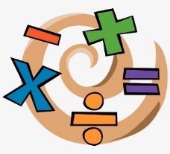
Science | 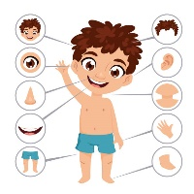 | 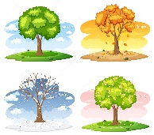 | In Science this half term, we will Identify and name the different arts of our bodies and their functions. We will also think about our senses, what they are and why we use them.  After half term, we will look at the weather outside and observe how the weather changes with the seasons.
History | In history this term, we will look at toys, homes, clothes and loads more as we discover how childhood has changed over the years. |  |  | 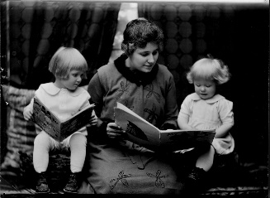
Geography | 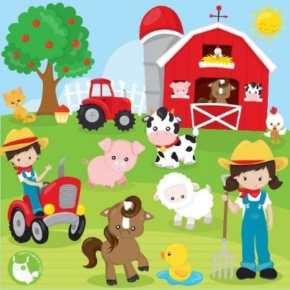 |  | In geography this term, we will learn about farms. We will think about the different types of farms, the features of a farm, how the seasons affect farmers as well as developing our maps skills and using a compass to give and follow directions.
Art | In Art this term, we will be learning about making marks. We will learn simple skills such as holding a pencil correctly for drawing before exploring mark making with a variety of mediums and materials. Children will go on to learn about the famous artist Paul Klee, imitating his techniques to create their own piece of art. |  |  | 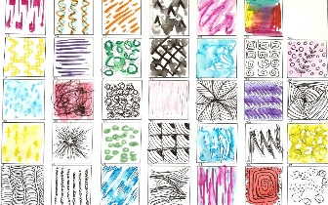
Design and Technology | 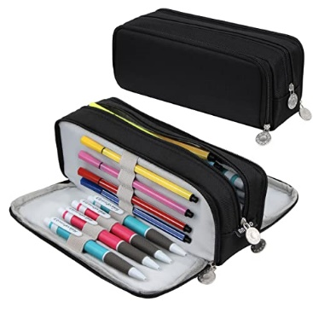 |  | In DT this term, we will be learning about homes.  We will look at a range of different homes before designing, making and evaluating our own, thinking carefully about how we can make our structure as strong as possible.
RE | In RE this term, we will be learning about the theme of ‘our wonderful world’. We will read stories, explore photographs of the world and discuss what they think makes our world special. |  |  | 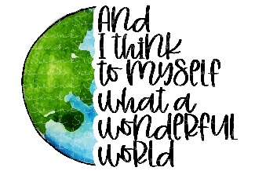
PE | 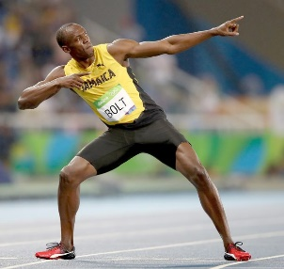 |  | In PE this term, we will think about developing our fundamental motor skills. We will focus on jumps and how we can jump and land safely.
PHSE | In PHSE this term, we will think about ‘being me’ and ‘celebrating differences’. We will think about what makes us special and unique and how this is different for everybody. |  |  | 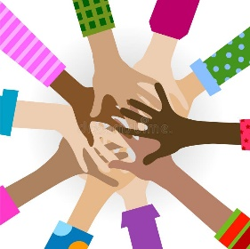
Computing | 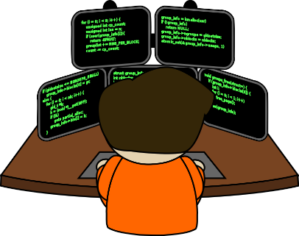 |  | This term in computing, we will learn about coding. We will learn about what coding is and how we can create codes which give computers instructions so that they know what to do.
Music | In music this term, we will take part in ‘little fingers’ workshops with a specialist music teacher. We will focus on developing our understanding of rhythm and pitch and we will have the opportunity to develop our ability in playing untuned instruments. |  |  | 