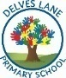
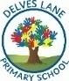
Year 2 Curriculum Map
 | Autumn 1 | Autumn 2 | Spring 1 | Spring 2 | Summer 1 | Summer 2
Class text | 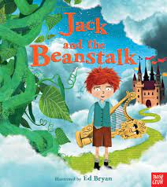 | 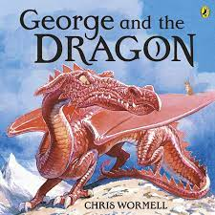 | 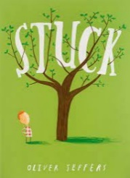 | 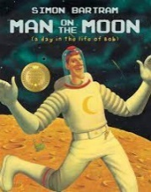 | 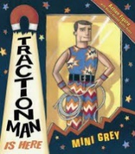 | 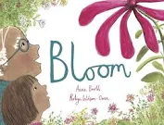
Writing | Fairy-tale narrative  Writing instructions on how to grow a beanstalk | Adventure narrative  Explanation text about how to train a dragon | Narrative  Explanation text about how to free something that is stuck | Space narrative  Diary entry  Non-chronological report about the moon | Superhero narrative  Character description about a superhero | Narrative  Non-chronological report about plants
Reading | Focus sounds: /ae/, /d/, /ee/, /i/ and <y>  Author of the term: Lauren Child | Focus sounds:  /oe/, /n/, /ie/ and /er/  Author of the term: Quentin Blake | Focus sounds:  /v/, /oo/, /j/ and /g/  Author of the term: Jeanne Willis | Focus sounds:  <g>, /f/, <gh> and /m/  Author of the term: Roald Dahl | Focus sounds:  /or/, /h/, /air/ and /k/  Author of the term: Mahri Hedderwick | Focus sounds:  /r/, /t/, /z/ and /eer/  Author of the term: Anthony Browne
Maths | Place Value  Addition and subtraction  Measurement: Money  Multiplication and division |  | Multiplication and division  Statistics  Geometry: Properties of shape  Fractions |  | Measurement: Length and Height  Geometry: Position and direction  Measurement: Time  Measurement: Mass, capacity and temperature
Science | Growth and Survival |  | Exploring everyday materials |  | Living in habitats | Growing plants
History | The Great Fire of London |  | Famous Queens |  | Florence Nightingale
Geography | Around the world |  | Let’s go on safari |  | Map Makers
Art & Design | Animal art |  | Super Sculptures |  | Self Portrait
Design & Technology | Puppets |  | Wacky Windmills |  | Perfect Pizzas
Computing | Computing systems and networks- IT around us | Creating media- Digital photography | Creating media- Making Music | Data and information- Pictograms | Programming A- robot algorithms | Programming B- An introduction to quizzes
Music | South African music | Festivals and  Christmas | Playing together in a band | Reggae and animals | A song about being friends | The history of music, look back and consolidate your learning, learn some of the language of music
PE | Racket Skills  (Rounders) | Movement skills | Dance | Ball skills  (football) | Ball skills  (football) | Athletics
 |  |  |  | Gymnastics
RE | Why is the bible special to Christians? | What can we learn from the story of St. Cuthbert? | What does it mean to belong to Christianity? | What does it mean to belong to Christianity? | How to Buddhists show their beliefs? | What can we learn about our local faith communities?
 |  | How and why is light important at Christmas? |  | How do Christians celebrate Easter?
PSHE/ RSE | Being me in my world | Celebrating differences | Changing me | Dreams and goals | Healthy me | Relationships

